CYB 400 2-3 Lab Worksheet
Andree Salvo
Southern New Hampshire University
CYB 400 – 13022
Instructor: Robert Chubbuck
Lab: Examining Wireless Networks
Prompt | Response
In the subsection “Parsing Object From Traffic,” Steps 4 and 5, add your initials at the beginning of the filename (for example, KSMsteph.jpg and KSMcurry.jpg). After closing the Wireshark HTTP object list window, minimize Wireshark and take a screenshot of the two files (***steph.jpg and ***curry.jpg) saved to the desktop. | 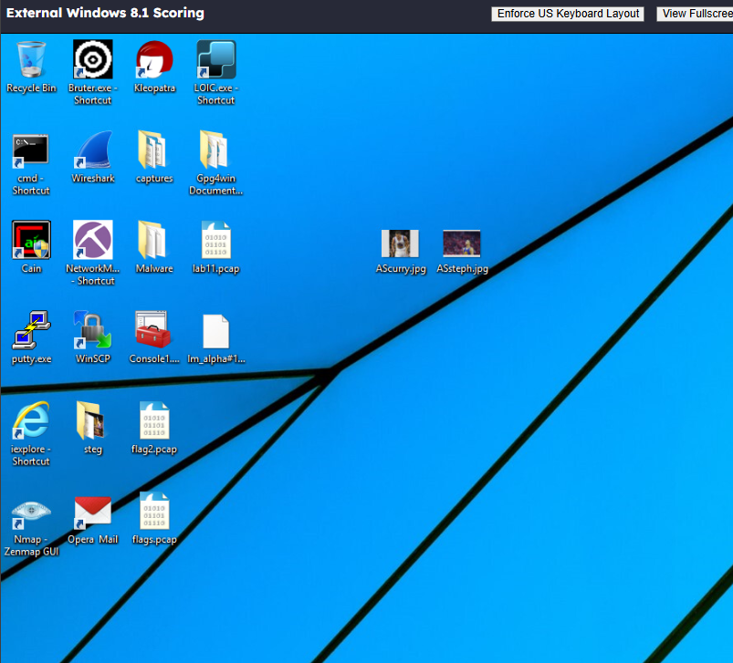
In the subsection “Parsing Object from Traffic,” Step 10, name the file using your initials followed by the number 1.pdf (for example, KSM1.pdf) and save it to the desktop. Take a screenshot of the desktop in Step 14 showing the PDF file. | 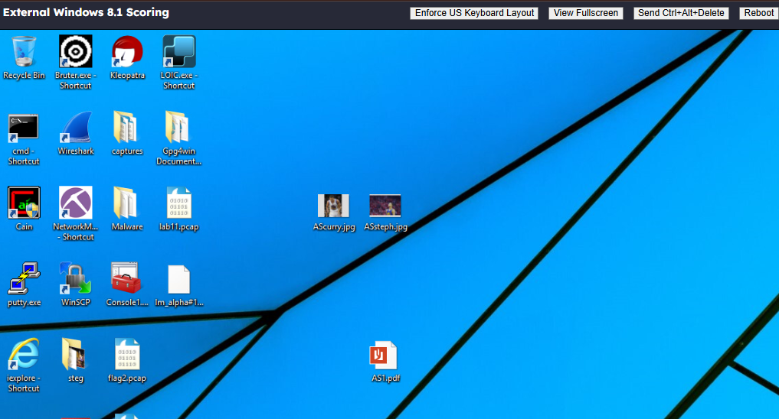
What is the significance of being able to parse information from the HTTP stream? | The significance of parsing information from the HTTP stream is significant because it allows you to analyze, monitor, and manipulate web traffic for purposes like debugging, security, and data extraction
What is the significance of being able to parse information from the FTP stream? | The significance of parsing FTP streams matters because it lets you track the activity, troubleshoot issues, and catch security risks/flaws.

Lab: Deep Dive in Packet Analysis—Using Wireshark and Network Miner
Prompt | Response
What is the significance of understanding how to decipher different protocol traffic? | In cybersecurity, being able to break down and understand protocol traffic is crucial. It helps you to understand how communications are talking with each other, spot any signs of suspicious activity, and catch potential risks early on. By doing this, you get a clearer picture of what “normal” system and user behavior looks like, which makes it easier to step in and cut down risks before they turn into bigger problems.
What is the significance of understanding the function of specific protocol port numbers? | Knowing port protocols is key to managing networks and keeping them secure. For example, each port has its own purpose, ensuring that traffic is directed to the correct applications and devices that can communicate properly. On top of that, understanding how ports work makes troubleshooting much easier and helps you put the right security measures in the right place and right time.

Lab: Vulnerability Scanning of Linux Target
Prompt | Response
In the subsection “Scanning the Network for Vulnerable Systems—Scanning the network using Nmap,” Step 23, take a screenshot of the output after scanning the IP protocols. | 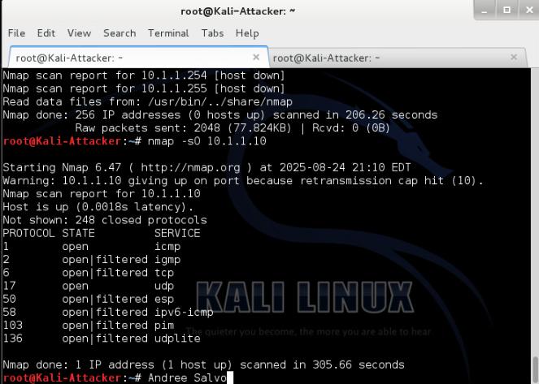
In the subsection “Scanning the Network for Vulnerable Systems—Scanning the Network Using Zenmap,” Step 5, take a screenshot of the output after running a ping scan on the 192.168.1.0/24 network. | 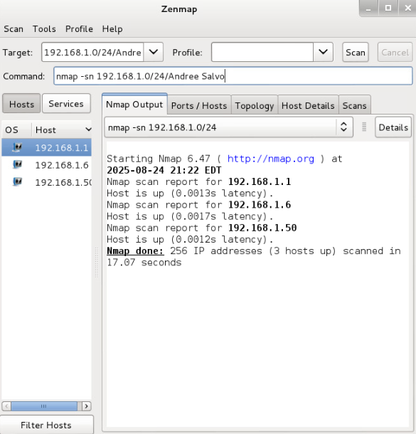
In the subsection “Scanning the Network for Vulnerable Systems—Scanning the Network Using Zenmap,” Step 16, take a screenshot of the output of the differences between the two scans. | 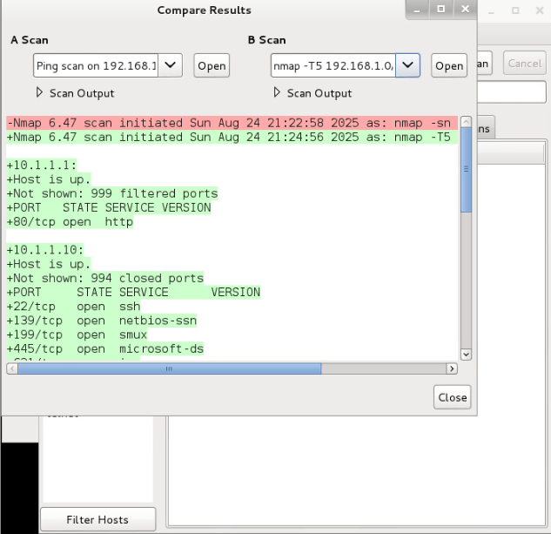
In the subsection “Scanning the Network Using OpenVAS—Scanning with OpenVAS,” Step 15, take a screenshot of the results after opening the SecInfo Management menu and opening the CVE’s window. | 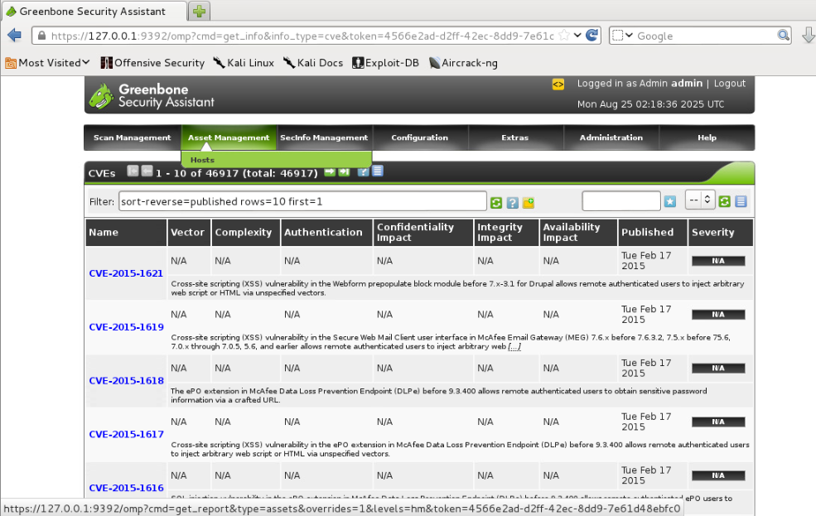
In the subsection “Scanning the Network Using OpenVAS—Create New Target,” Step 8, take a screenshot of the results showing the newly created Ubuntu target. | 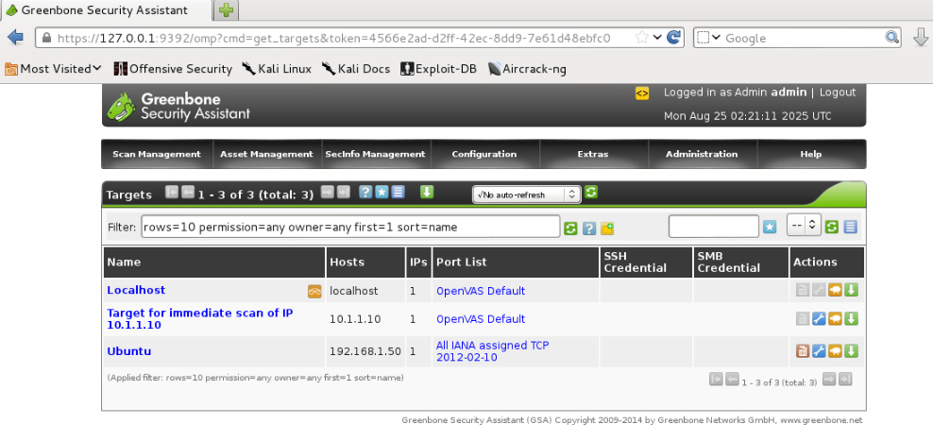
In the subsection “Scanning the Network Using OpenVAS—Create New User,” Step 10, take a screenshot of the window showing the new user, Analyst1. | 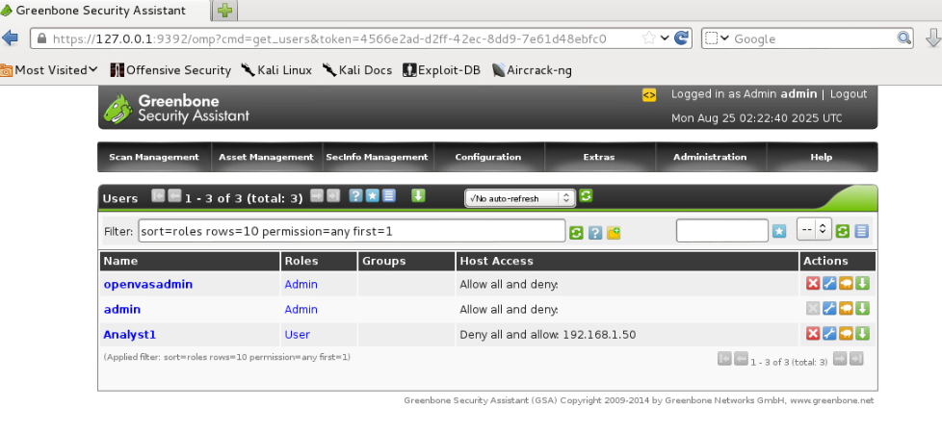
In the subsection “Scanning the Network Using OpenVAS—Create New Schedule,” Step 9, take a screenshot of the window showing the new scan scheduled for Ubuntu discovery. | 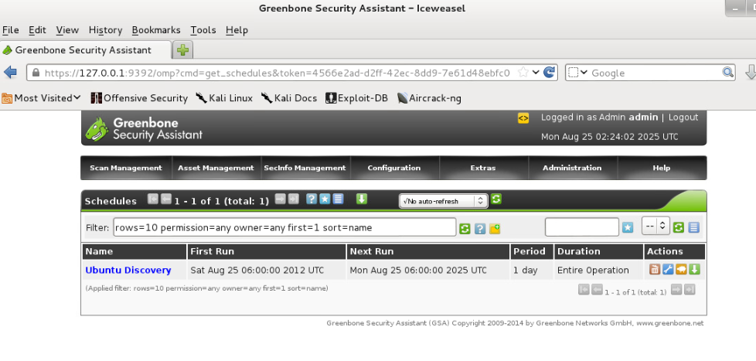
In the subsection “Scanning the Network Using OpenVAS—Analyzing the Scan Report,” Step 5, take a screenshot of the scan results for 10.1.1.10 showing the vulnerabilities. | 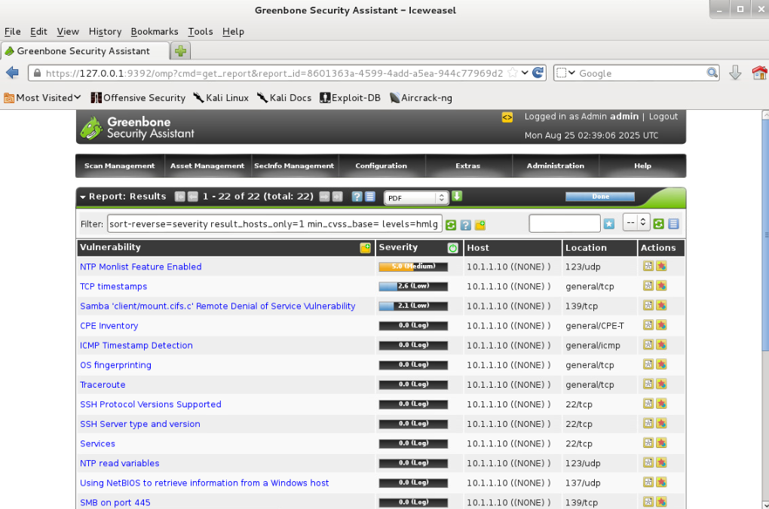
Several different switches were used when running the nmap command in the lab. Pick three different switches and explain the functionality of each one. | - Nmap –O {target} figures out what OS it detects, like (Linux or Windows).  - Nmap -p 80 <target> scans for all hosts that’re both Internal and DMZ.  - Nmap –sV <target> detects which service and version is running on open ports.
What is the difference in functionality between the use of nmap and the use of OpenVAS? | The difference between the two is that Nmap is a network scanner for discovering hosts and services, while OpenVAS is a vulnerability scanner that identifies security flaws.

